PASTA PARTY
We are pleased to announce that our annual Pasta Party has
been booked for Tuesday 18th April 2017 at The Sun Inn
(Winchester Road, Romsey SO51 7JG) at 7pm for 7.30pm sit down to eat.
(Parking available behind the pub.)
There’ll be a set menu, at a special price of just £10.00 per head
(drinks, desserts and coffee can be ordered and paid for separately on the night).
If you wish to come along and support our London Marathon and Southampton Half Marathon/Marathon entrants, please complete the form below and hand it to David Nixon or Liz Slade by Thursday 13th April – along with payment details (cheques made payable to Romsey Road Runners). Please let us know if you have any special dietary requirements.
MENU
Beef lasagne
Mild Bean Chilli with Rice (suitable for gluten free and lactose intolerant)

Garlic bread

Green Salad

Please let us know if you have any other dietary requirements (the pub is very accommodating)

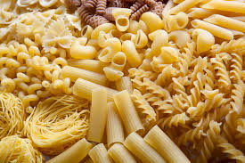
....................................................................................................................................................

NAME/S:......................................................................................................................................
Please reserve me/us ........... place(s) at the RRR Pasta Party at The Sun Inn on Tuesday 18th April 2017.
Special dietary requirements:………………………………………………………………..................................
……………………………………………………………………………………………………………………………………………….
I/we have enclosed cash/cheque (made payable to ‘Romsey Road Runners’)/paid online for:
£............................

